BOT GOLD
14.11.2023

It has retraced the Fib and price action looks promising :

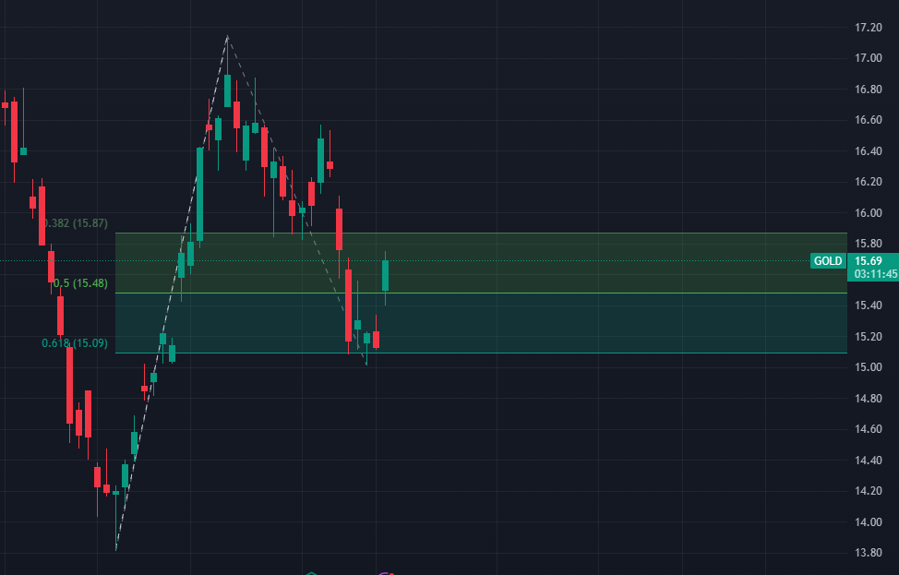
It could easily go to 17 and beyond by early Dec

Notice that Call 16 is cheaper than Call 17 (29 % vs 31 % IV)

For Dec 15 expiration :

